**No Building Found -Citizen Login**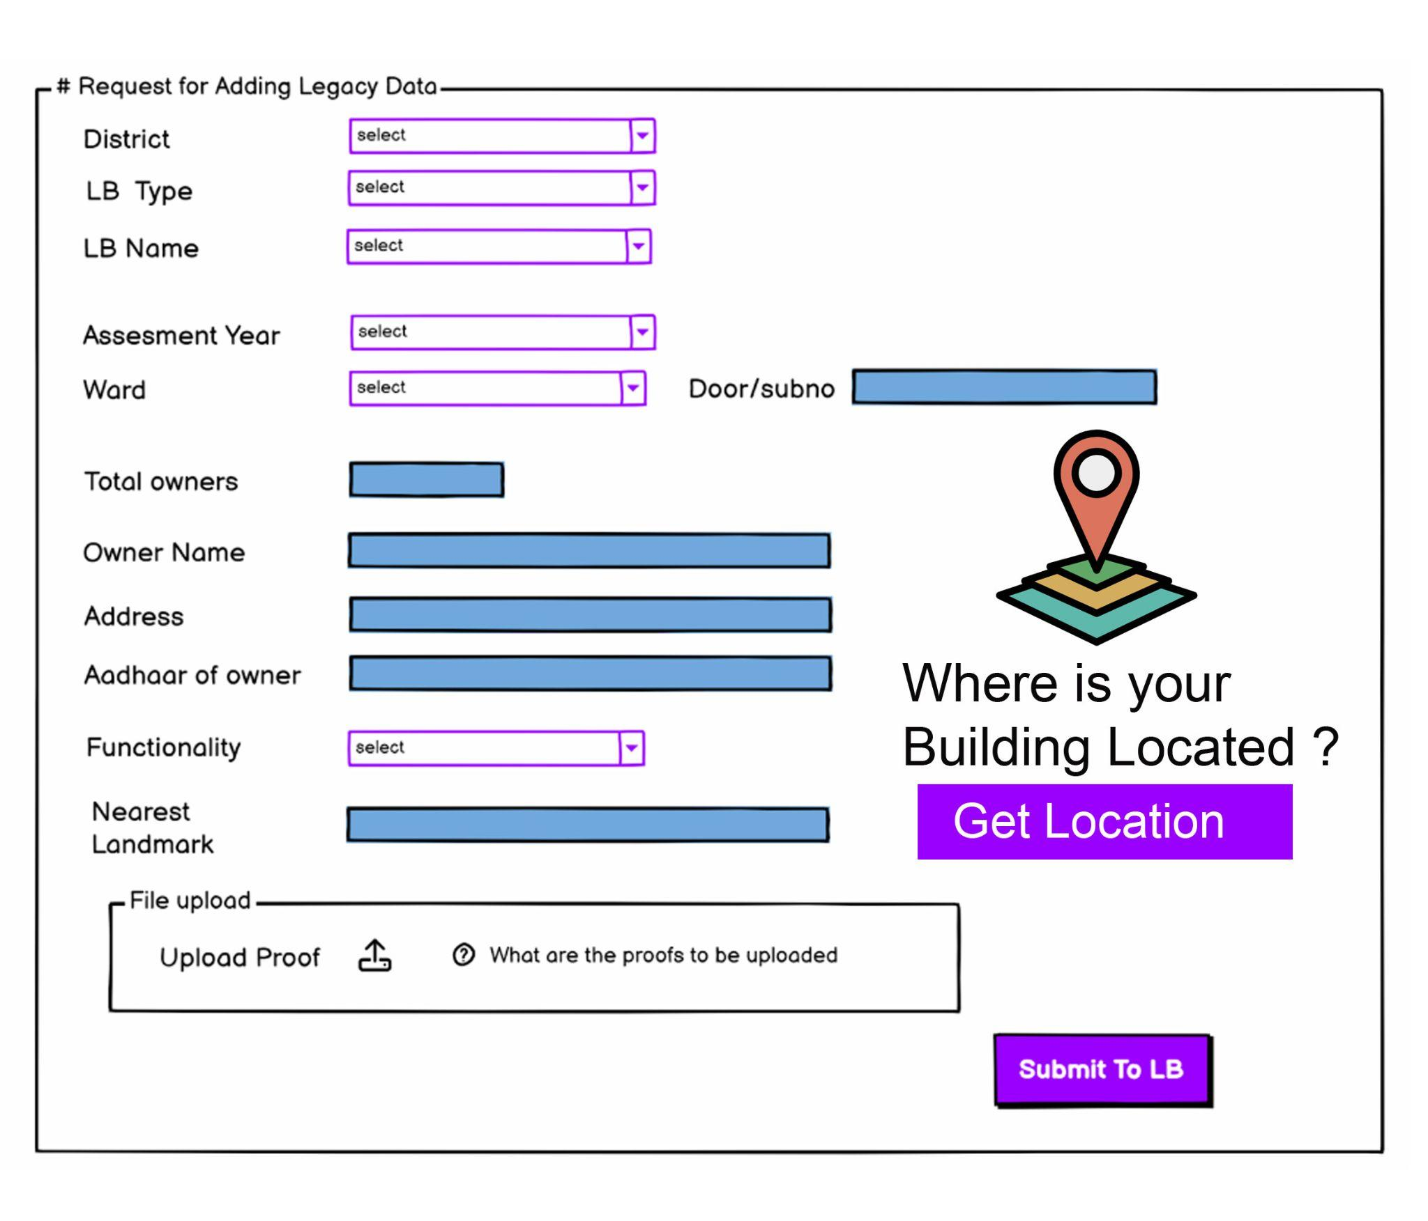

**No Building Found –Operator login**

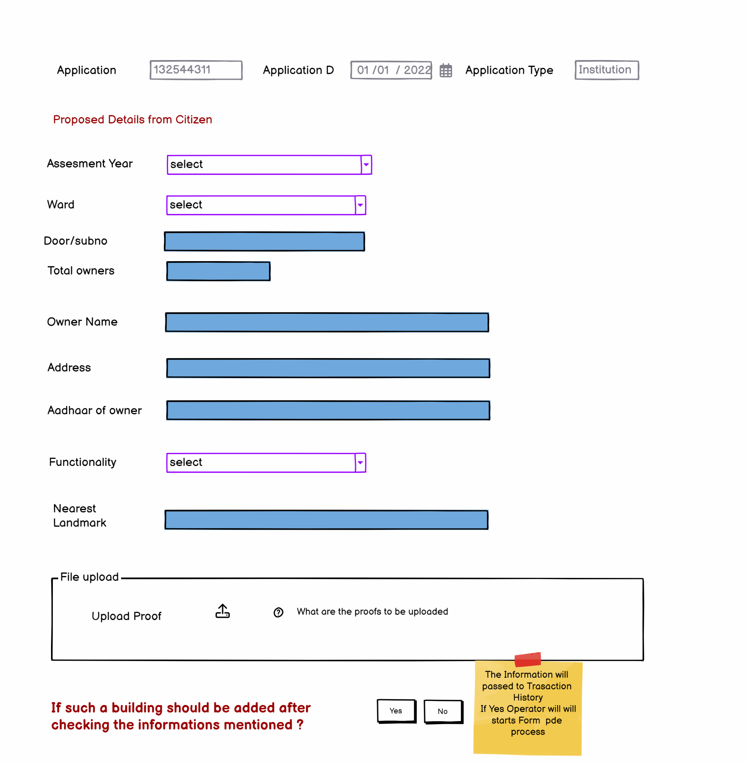

* The local body should initiate a process to identify the building
* Necessary arrangements shall be done to include the building in the assessment register

Form 2 part 1

Tax Assessment Part 1

Structure ID: SXXXXXXX

Permit No : BXXXXXXXX Date: 22/01/2020

Kochi Corporation, Eranakulam

Ward No: 4

Occupancy Certificate: OXXXXX

Owner Details

Rajesh K,Kunhimangalam, Kannur

**Occupancy Certificate Details**

Total Area: 1900 sqft

Total Taxable Area :1750 sqft

Hi Ramesh,

You can Select the entire building as a Single Door No

Or

Select the Portion as you wish to get numbers



Residential

50 sqft

Residential occupancy

Commercial occupancy

Hazard occupancy

Assembly Occupancy

Residential

100 sqft

Commercial

150 sqft

Commercial

50 sqft

Commercial

50 sqft

Ground

Floor

Residential

50 sqft

Actions

Create

New Door No

Commercial

50 sqft

Commercial

50 sqft

Commercial

50 sqft

First Floor

Cellar

Commercial

50 sqft

Commercial

50 sqft

Commercial

50 sqft

Commercial

50 sqft

**Cart**

First Flr

50 sqft

**Door No 1**

Ground Flr

50 sqft



Usage Type

Save

Floor Type

Roof Type

Centralised A/C



**Door Numbers Selected**

Structure ID

SXXXXX

Floor No

Floor1

Occupancy

Residential A1

Functionality

Quarters

Door No : 1

Area Sqm

50

Action

SlNo

1

SXXXXX

Ground

Residential A1

Quarters

50

2

Door No : 2

SXXXXX

Ground

Commercial

Shop

50

1

NEXT>>

Zone

Road details

Biogas/Bio compost - Yes / No

**\*\*\* ALTERNATE MODEL TO REPRESENT FORM 2 DATA -** *In this model , actual building plan is shown on the right side with the facility to click and select a portion . it's a click and selectable image generated from the Building plan values.*